Octobers' 1965 to 1970 - Marine Tanks & Ontos Action
This is the seventh of what is intended to be a monthly feature of abstracted Tank and Antitank Command Chronologies. This Breech Block – October 2013 – will give you a brief overview of the action in which the 1st, 3rd, and 5th Tanks and Antitanks were involved in during each October that they were in-country. For the complete command chronologies, please visit our Foundation website http://www.mcvthf.org where Pappy Reynolds has posted the Tank and Antitank CCs. Most of the CCs are 100-300 pages in length with material that is of only marginal interest to most. I will attempt to feature that data which is of prime interest. If we’ve omitted areas that you would like to see included in these monthly abstracts, please let us know. If you served in Tank or Ontos units during a month of October and can recall some experiences that you would like others to read jot them down and send them to us. Pictures with captions are of particular interest. Nearly all of the material you send us will find its way into one of our publications and The Book.
Please note that, the Battalion Command Chronologies routinely list all the principle staff officers. However, we will provide only the C.O.’s, X.O.’s, Operations, and Logistics Officers. Also, you will see the names of the C.O.s of H&S and the letter companies. It is our hope that our readers (and would-be authors) who can recall the names of their Officer, Staff NCO, and NCO Leaders as well as others with whom they served, will send us their names. Those Marines are a part of our history which needs to be made known. We serve our Brothers well by recording their names in history.
Also, you are encouraged to access the Foundation’s Map Chronology that Pappy has created http://www.mcvthf.org. There you may find out exactly where your unit - battalion, company, often platoon, and occasionally section - was located at any given time. If you do not find your unit on one of Pappy’s several maps, let us know. Also is plotted the exact location and statistics of every Tanker and Ontos crewman who was killed in action.
And finally, you will note that the abstracts may looks a bit "ragged" with the cut and paste of the original Command Chronologies into the abstract format. Aside from the fact that we do not have the time and available person power to re-type the CC's reports, with the original CCs posted as written we have obviated typing errors. The cut/paste gives you exactly how the CC was typed at the company and battalion headquarters some 44-48 years ago. (Here place the link to the Tank & ATs Command Chronologies for September that follow)

October 1966

First Tanks:
Commanding Officer: LtCol J.W. Clayborne
Executive Officer: Maj R.D. McKee
Operations Officers: Capt's R.G. McPherson & F.U. Salas
Logistics Officers: Maj T.M. Bryant & Capt G.E. Hooker
Battalion CP Da Nang (AT 998722)
H&S C.O.: Maj J.P. McGill
Location: Same as Bn CP
C.O. Company “A”: Capt C.R. Brabec
Location: Chu Lai (BT 515040)
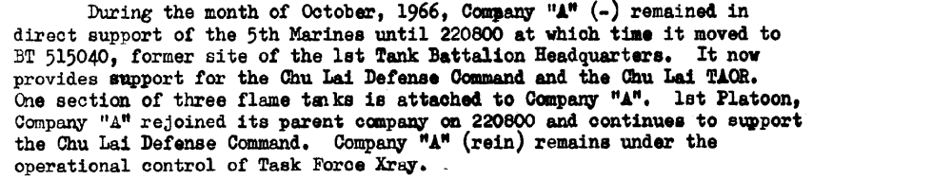

C.O. Company “B”: Capt L.E. Cherico
Location: Da Nang (AT 945763)

C.O.s Company “C”: Capt F.U. Salas & 1stLt C.E. Barnett
Location: Da Nang (BT 066715)
October 1967

First Tanks:
Commanding Officer: LtCol R.M. Taylor
Executive Officer: Maj V.J. Gentile
Operations Officer: Maj R.M. Croll
Logistics Officer: Maj J.A. SchuyLer
Location: Da Nang (AT 977723)

H&S C.O.: Capt C.R. Casey
Location: Da Nang (AT 997723) Same as Bn CP.

C.O. Company “A”: Capt R.W. Maddox
Location and Operations Summary: Tam Ky (BT 133445) & Da Nang (977723)
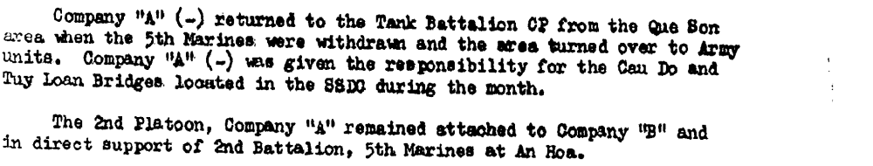

C.O. Company “B”: Capt R.E. Roemer
Location and Operations Summary: Da Nang (AT 962621)

C.O. Company “C”: Capt R.D. Gunselman
Location and Operations Summary: Da Nang (BT074659)

October 1968

First Tanks:
Commanding Officer: LtCol M.C. Ashley, Jr
Executive Officer: Maj R.H. Graham
Operations Officers: Maj J.T. Garcia & Capt J.B. Terpak
Logistics Officer: Maj D.R. Sparks
Location and Operations Summary: CP (AT 997723)
The 4 major operations were: Gerrard Bay. Co. "C" in support of 2/1
Mameluke Thrust. Co. "B"
Henderson Hill. Co. "B"
Maui Peak. Co. "B "
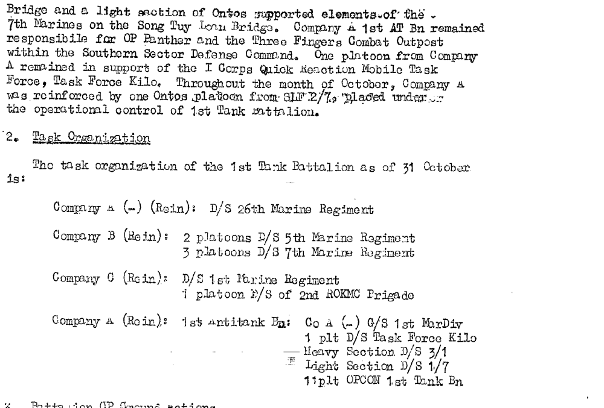

H&S Company C.O.s : Capt's R.A. Doyle & J.K. Marlatt & Maj B.E. Davidson
Location and Operations Summary: CP (AT 997723)
C.O. Company “A”(-)(Rein): Capt B.R. Montgomery
Location and Operations Summary: CP (AT 936782)
C.O.s Company “B” (Rein): Capt's D.G. Henderson & R.A. Doyle
Location and Operations Summary: CP (AT 962621)
C.O. Company “C” (Rein): Capt R.T. Hopkins
Location and Operations Summary: CP (BT 078663)
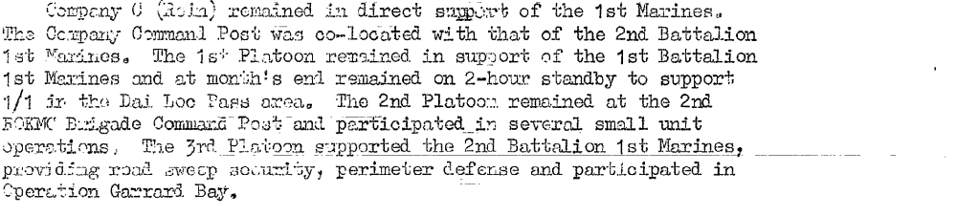
C.O.s Company “A”, 1st AT Bn: 1st G.B. Search & Capt F.P. Briseno
Location and Operations Summary: CP (AT997723)
October 1969

First Tanks:
Commanding Officer: LtCol L.R. Butler
Executive Officer: Maj R.D. Becker
Operations Officer: Maj J.P. Senik
Logistics Officer: Maj G.E. Berbaum
Location and Operations Summary: Da Nang (AT 997723)

H&S C.O.: Maj H.G. Duncan
Location and Operations Summary: Da Nang (AT 997723) Same as Bn CP.
C.O. Company “A” (-): 1stLt P.H. McMath
Location and Operations Summary: CP (AT 997723)
C.O. Company “B” (Rein): 1st Lt J.M. Lidyard
Location and Operations Summary: CP (AT 962621)
C.O.s Company “C” (Rein): Capt's J.K. Marlatt &T.W. Kelly
Location and Operations Summary: CP (BT 135454)
C.O.s Company “A” (Rein), 1st AT Bn: 1stLt's B.J. Bethel & r.B. Goodrich
Location and Operations Summary: CP (AT 997723)
C.O. Company “A” (-), 5th Tank Bn: Capt M.F. Shisler
Location and Operations Summary: CP (AT 997723)

October 1965

First Antitanks:
Commanding Officer: LtCol W. Moore
Executive Officer: Maj R.E. Harris
Operations Officer: Maj A.J. Eagan
Logistics Officer: Maj J.J. Keefe
Location & Operations Summary: Camp Pendleton, CA

H&S Company C.O.: Capt J.W. Schroeder
Location: Camp Pendleton, CA

C.O. Company “A”, 1st AT Bn: 1stLt B.J. Bethel

C.O. Company “B”, 1st AT Bn: 2ndLt F.S. Roe

C.O. Company “C” 1st AT Bn: 1stLt W.F. Snyder

Note: The month of October is included in the un-formatted "Command Chronology - July thru December 1965". The document is a narrative with no specific, format making it difficult to summarize. However, the narrative style is quite comprehensive and covers much more detail than the formatted CC. Plus the chain of comand includes the platoon leaders which is largely absent from the norm for CC's. For those interested in details of this period of 1st AT you are encouraged to access the Foundation's web site at http://www.mcvthf.org, go to the command chronologies page and follow the prompts to the applicable chronology.

October 1966

First Antitanks:
Commanding Officer: Maj R.E. Harris
Executive Officer: Maj M.F. Manning
Operations Officer: Maj J.J. Burke, Jr.
Logistics Officer: Capt C.R. Vanhorn
Location & Operations Summary:

Note: To attempt to summarize the Command Chronology of 1st AT's is an injustice. The Ontos were everywhere! There was no job too large or too small for the ontos to be involved. The command chronologies are detailed down to names of crews. This level of detail is found nowhere else in the archives of command chronologies. If you want to research further into the actions of Ontos you are encouraged to read the complete command chronologies, accessed through the Foundation's web site. Tank CCs are up to 400+ pages much of which is of slight interest (being generous) to most. However, the Ontos CCs are 13+ pages long and they are action filled and detailed. To complicate reporting, the Ontos Battalions were phased out halfway through the war and their actions strained through the sieve of the supporting respective Tank Battalions. From that point on, Tank's CCs mostly mentioned the attached Ontos in passing and very little of what the Ontos did was reported in any great detail.

H&S Company C.O.: 1stLt M.H. Collier
Location & Operations Summary: Camp Pendleton, CA

C.O. Company “A”(-): Capt D.M. Hutson

C.O. Company “B" (Rein): Capt T.F. Dempsey
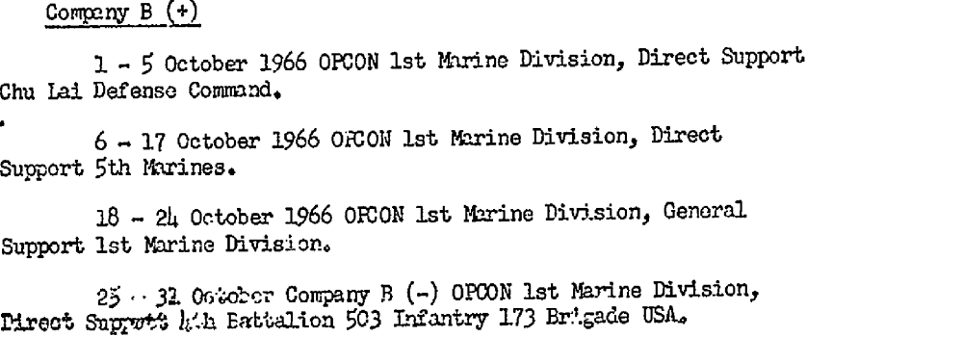

C.O. Company “C”: Capt R.J. Esposito

October 1967

First Antitanks:
Commanding Officer: LtCol P.D. Reissner, Jr.
Executive Officers: Maj's P.S. Galligan & P.G. Padke
Operations Officer: Cpat G.K. Robinson, Jr.
Logistics Officer: 1stLt V.C. Davis
Location & Operations Summary:
Note: Unique to the Ontos Battalion was its approach to producing the monthly command chronologies. First, they are more narative and reader friendly. Second, the companies submit their command chronologies and they appear in whole as annexes to the battalion's.

H&S Company C.O.: Cap B.A. Vredeveld
Location:

C.O. Company “A”(-): Capt C.E. Woods
Location: Quang Tri
C.O. Company “B" (Rein): Capt A.R. Green, Jr.
Location: Hill 63, Quang Tin & Duong Son
C.O. Company “C”: Capt W.E Nelson
Location: Da Nang

October 1965

Third Tanks
Commanding Officer: LtCol M.L. Raphael
Executive Officer: Maj J.G. Doss, Jr.
Operations Officers: Capt J.B. Donovan, Jr. & Maj H.L. Maxwell
Logistics Officer: Maj F.W. Coates
Location & Operations Summary: DaNang (AT 991710)

H&S Company C.O.: Capt H.A. Bertrand Jr.
Location: Da Nang (AT 991710)

C.O. Company “A”: Capt F.W. Jarnot
Location: Da Nang (AT 946762)
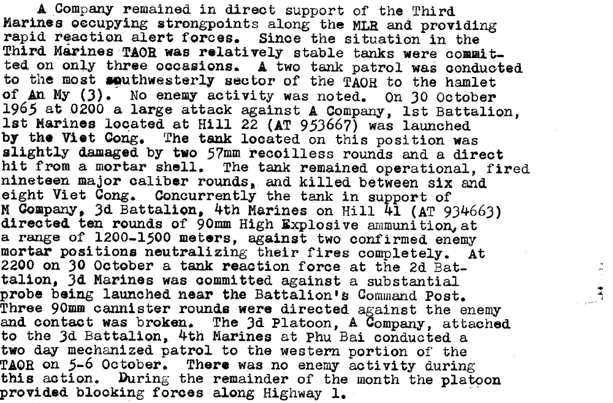

C.O. Company “B”: Capt A.E. Lee
Location: Da Nang (AT 067710)

C.O.s Company “C”: 1stLt J.D. Sparks & Capt E.L. Erickson
Location: Chu Lai (BT 531094)
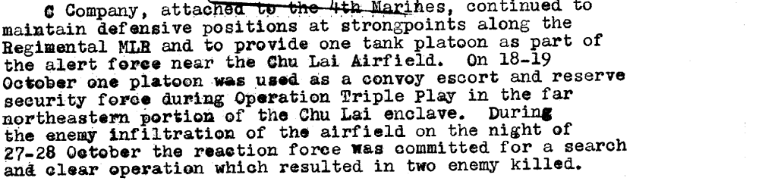

C.O. Company "B", 1st Tanks: Capt A.L. Lamb
Location: Chu Lai (BT 548060)
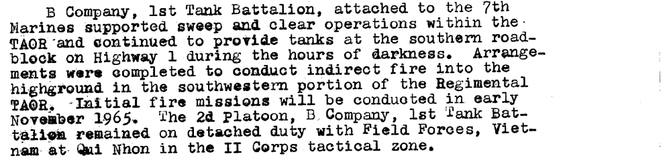

October 1966

Third Tanks
Commanding Officer: LtCol W.R. Corson
Executive Officers: Maj's J.G. Doss, Jr. & E.R. Larson
Operations Officers: Maj's Maj E.R. Larson & E.L. Tunget
Logistics Officers: Capt R.E. Downard & 2ndLt R.J. Bright
Location & Operations Summary: DaNang (AT 989708)
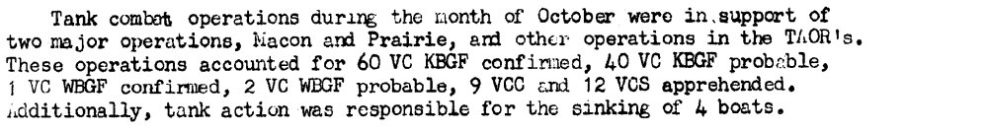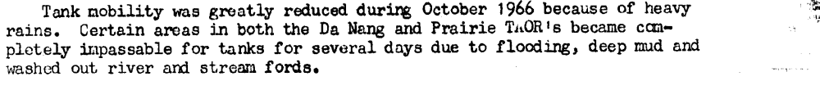
H&S Company C.O.s: 1stLt's M.F. Beirne IV & R.D. McDaniel
Location & Operations Summary: DaNang (AT 989708)

C.O.s Company “A”: Capt A.W. Facklam Jr.
Location & Operations Summary: Prairie (YD 063544)
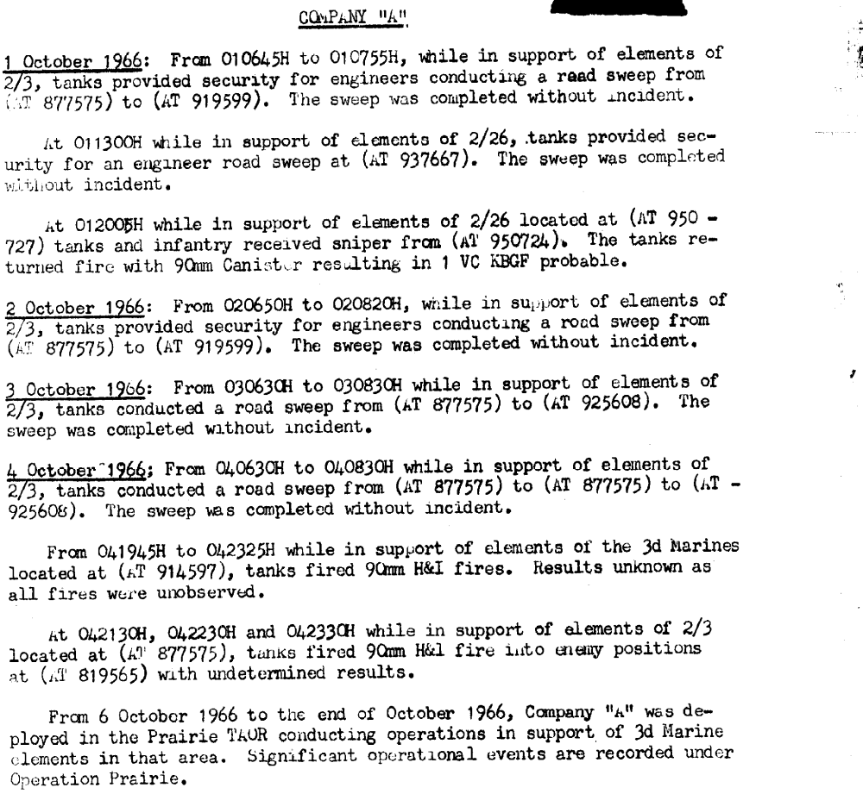
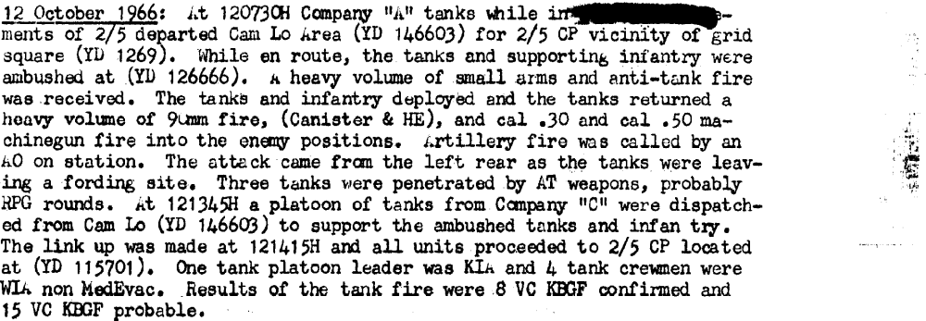

C.O.s Company “B”: Capt E.L. Tunget & 1stLt D.B. Garner
Location & Operations Summary: DaNang (AT 962611)
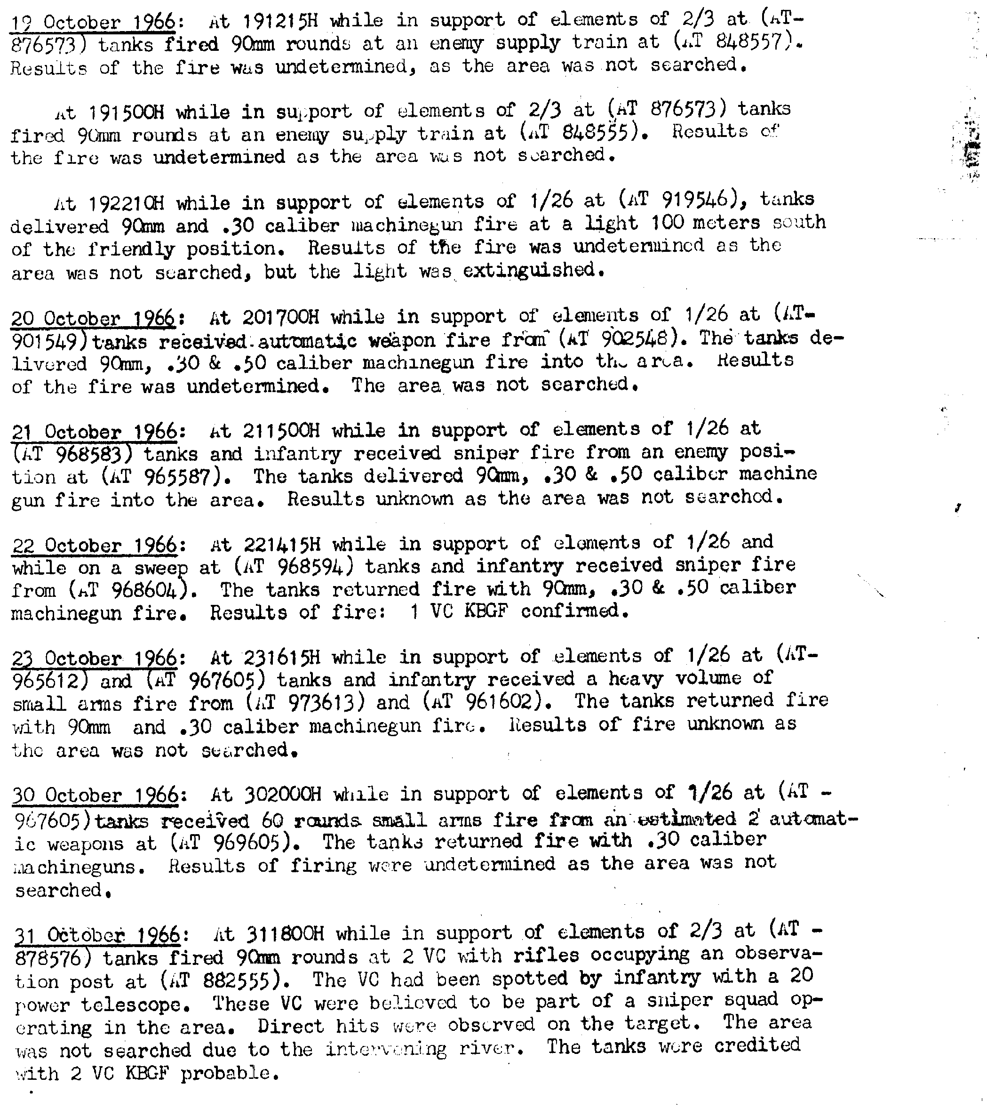

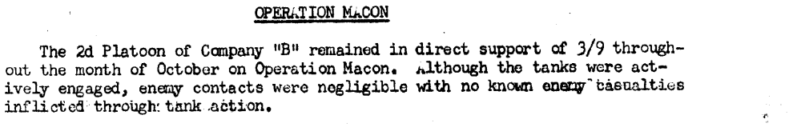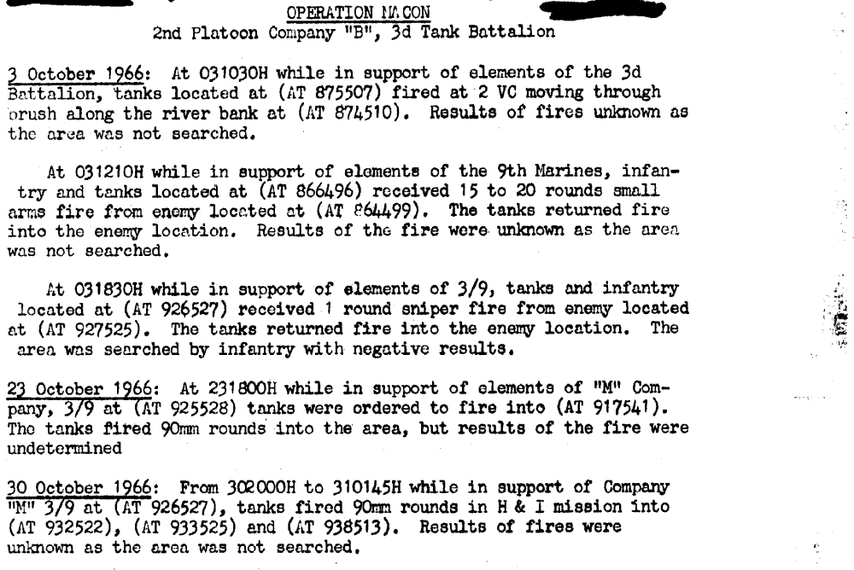

C.O. Company “C”: Capt P.F. Lassard
Location & Operations Summary: Prairie (YD 246599)

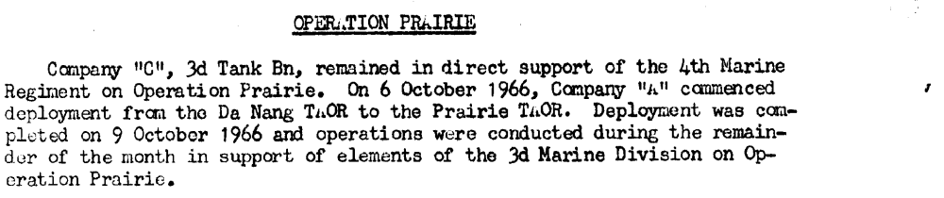
October 1967

Third Tanks
Commanding Officer: LtCol F.D. Chapman
Executive Officer: Maj B.M. MacLaren
Operations Officers: Capt C.L. Sale & Maj C.J. Samulesen
Logistics Officer: Maj R.E. Finney
Location & Operations Summary: Phu Bai
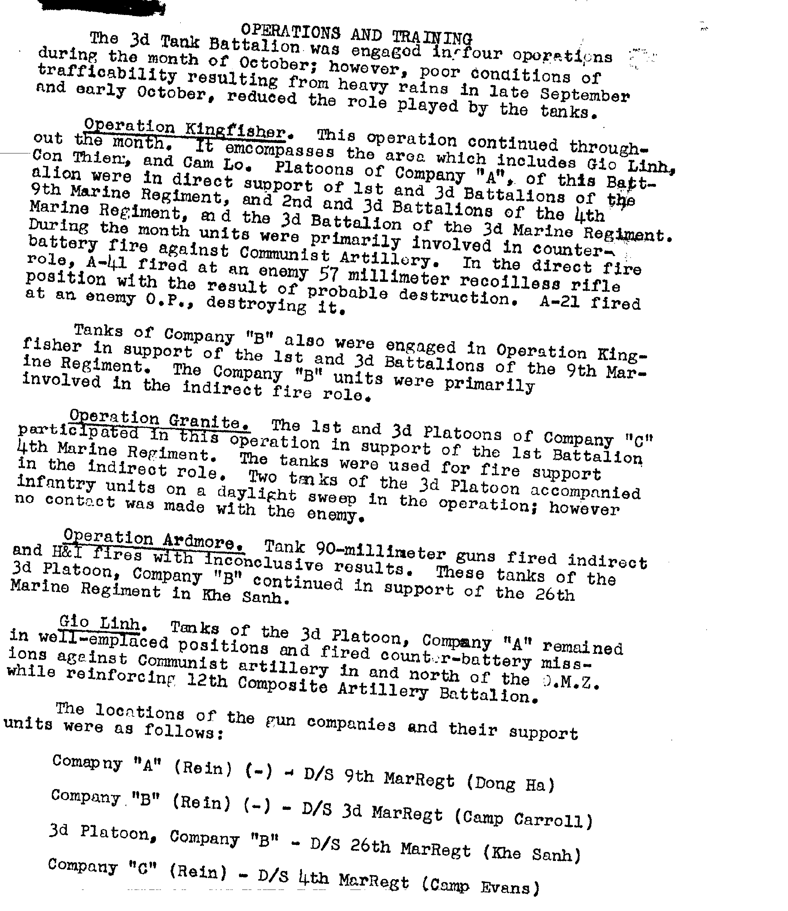

H&S Company C.O.: 1stLt A.W. Hauser
Location & Operations Summary: Phu Bai

C.O.s Company “A”: Capt's G.G. Jacobsen & G.W. Baker
Location & Operations Summary: Dong Ha

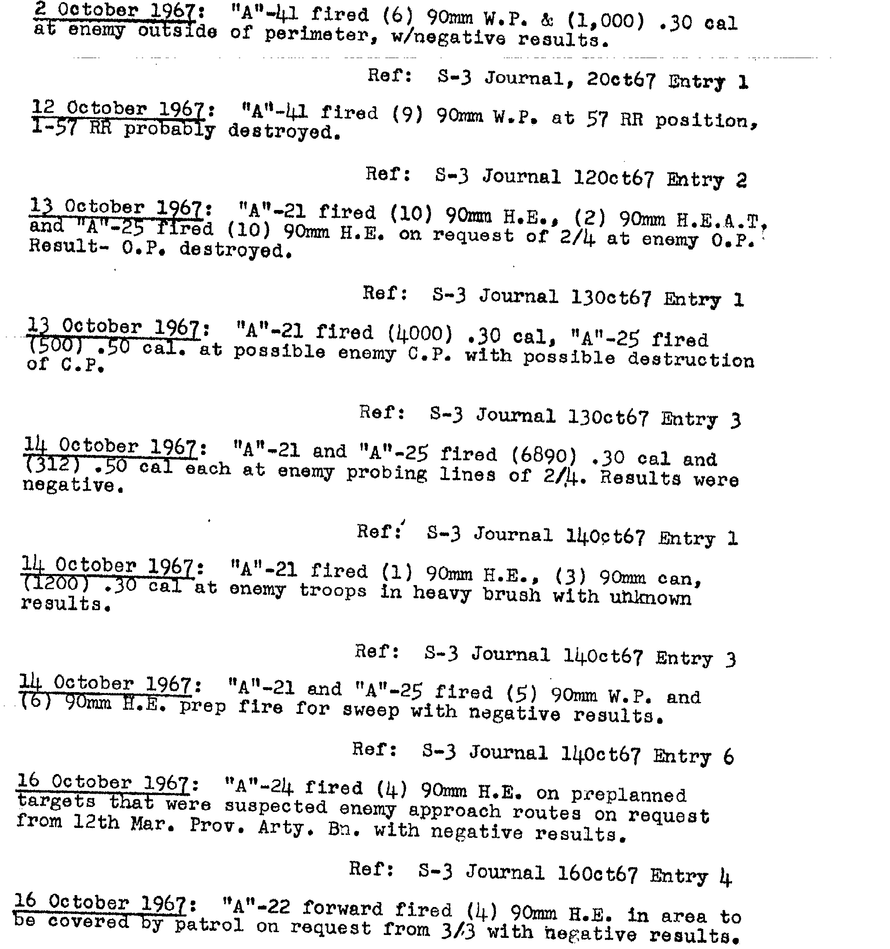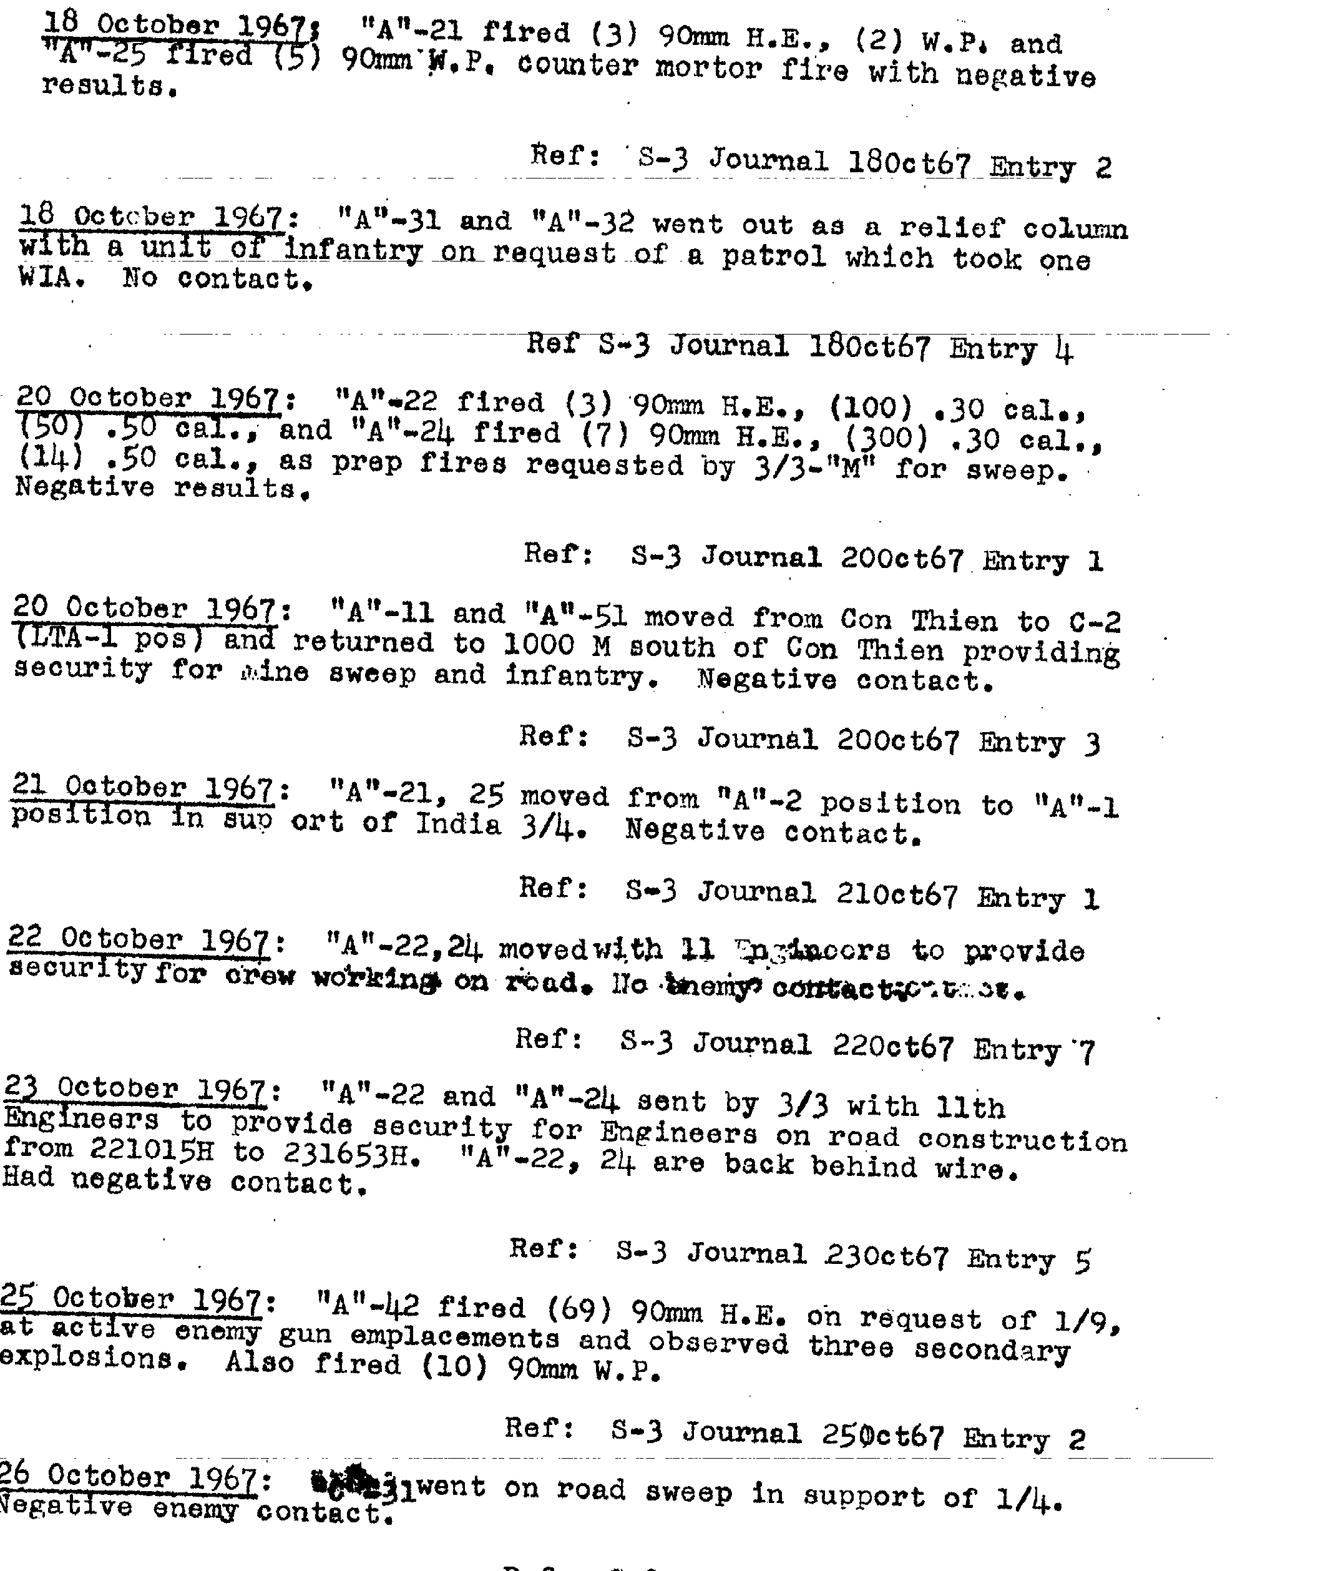

C.O. Company “B”: Capt E.J. Kline
Location & Operations Summary: Camp J.J. Carroll

C.O. Company “C”: Capt W.J. O'Buch
Location & Operations Summary: Phong Dien
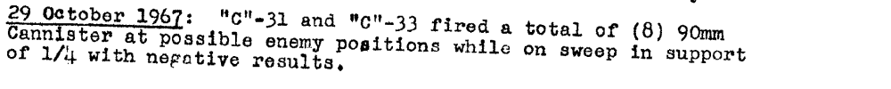

Note: The "Sequential Listing of Significant Events" is presented here in its entirity. The Command Chronology for this period has shortened the entries and, as an alternative has supplied the S-3 Journal reference for more detail. You are encouraged to access the CC at the Foundation web site http://www.mcvthf.org for more detail.
October 1968

Third Tanks
Commanding Officer: LtCol G.E. Hayward
Executive Officers: Maj's C.J. Samuelsen & J.P. Souders
Operations Officers: Maj's J.P. Souders & H.L. Bauknight
Logistics Officer: Maj W.A. Grubbs
Location & Operations Summary: Quang Tri
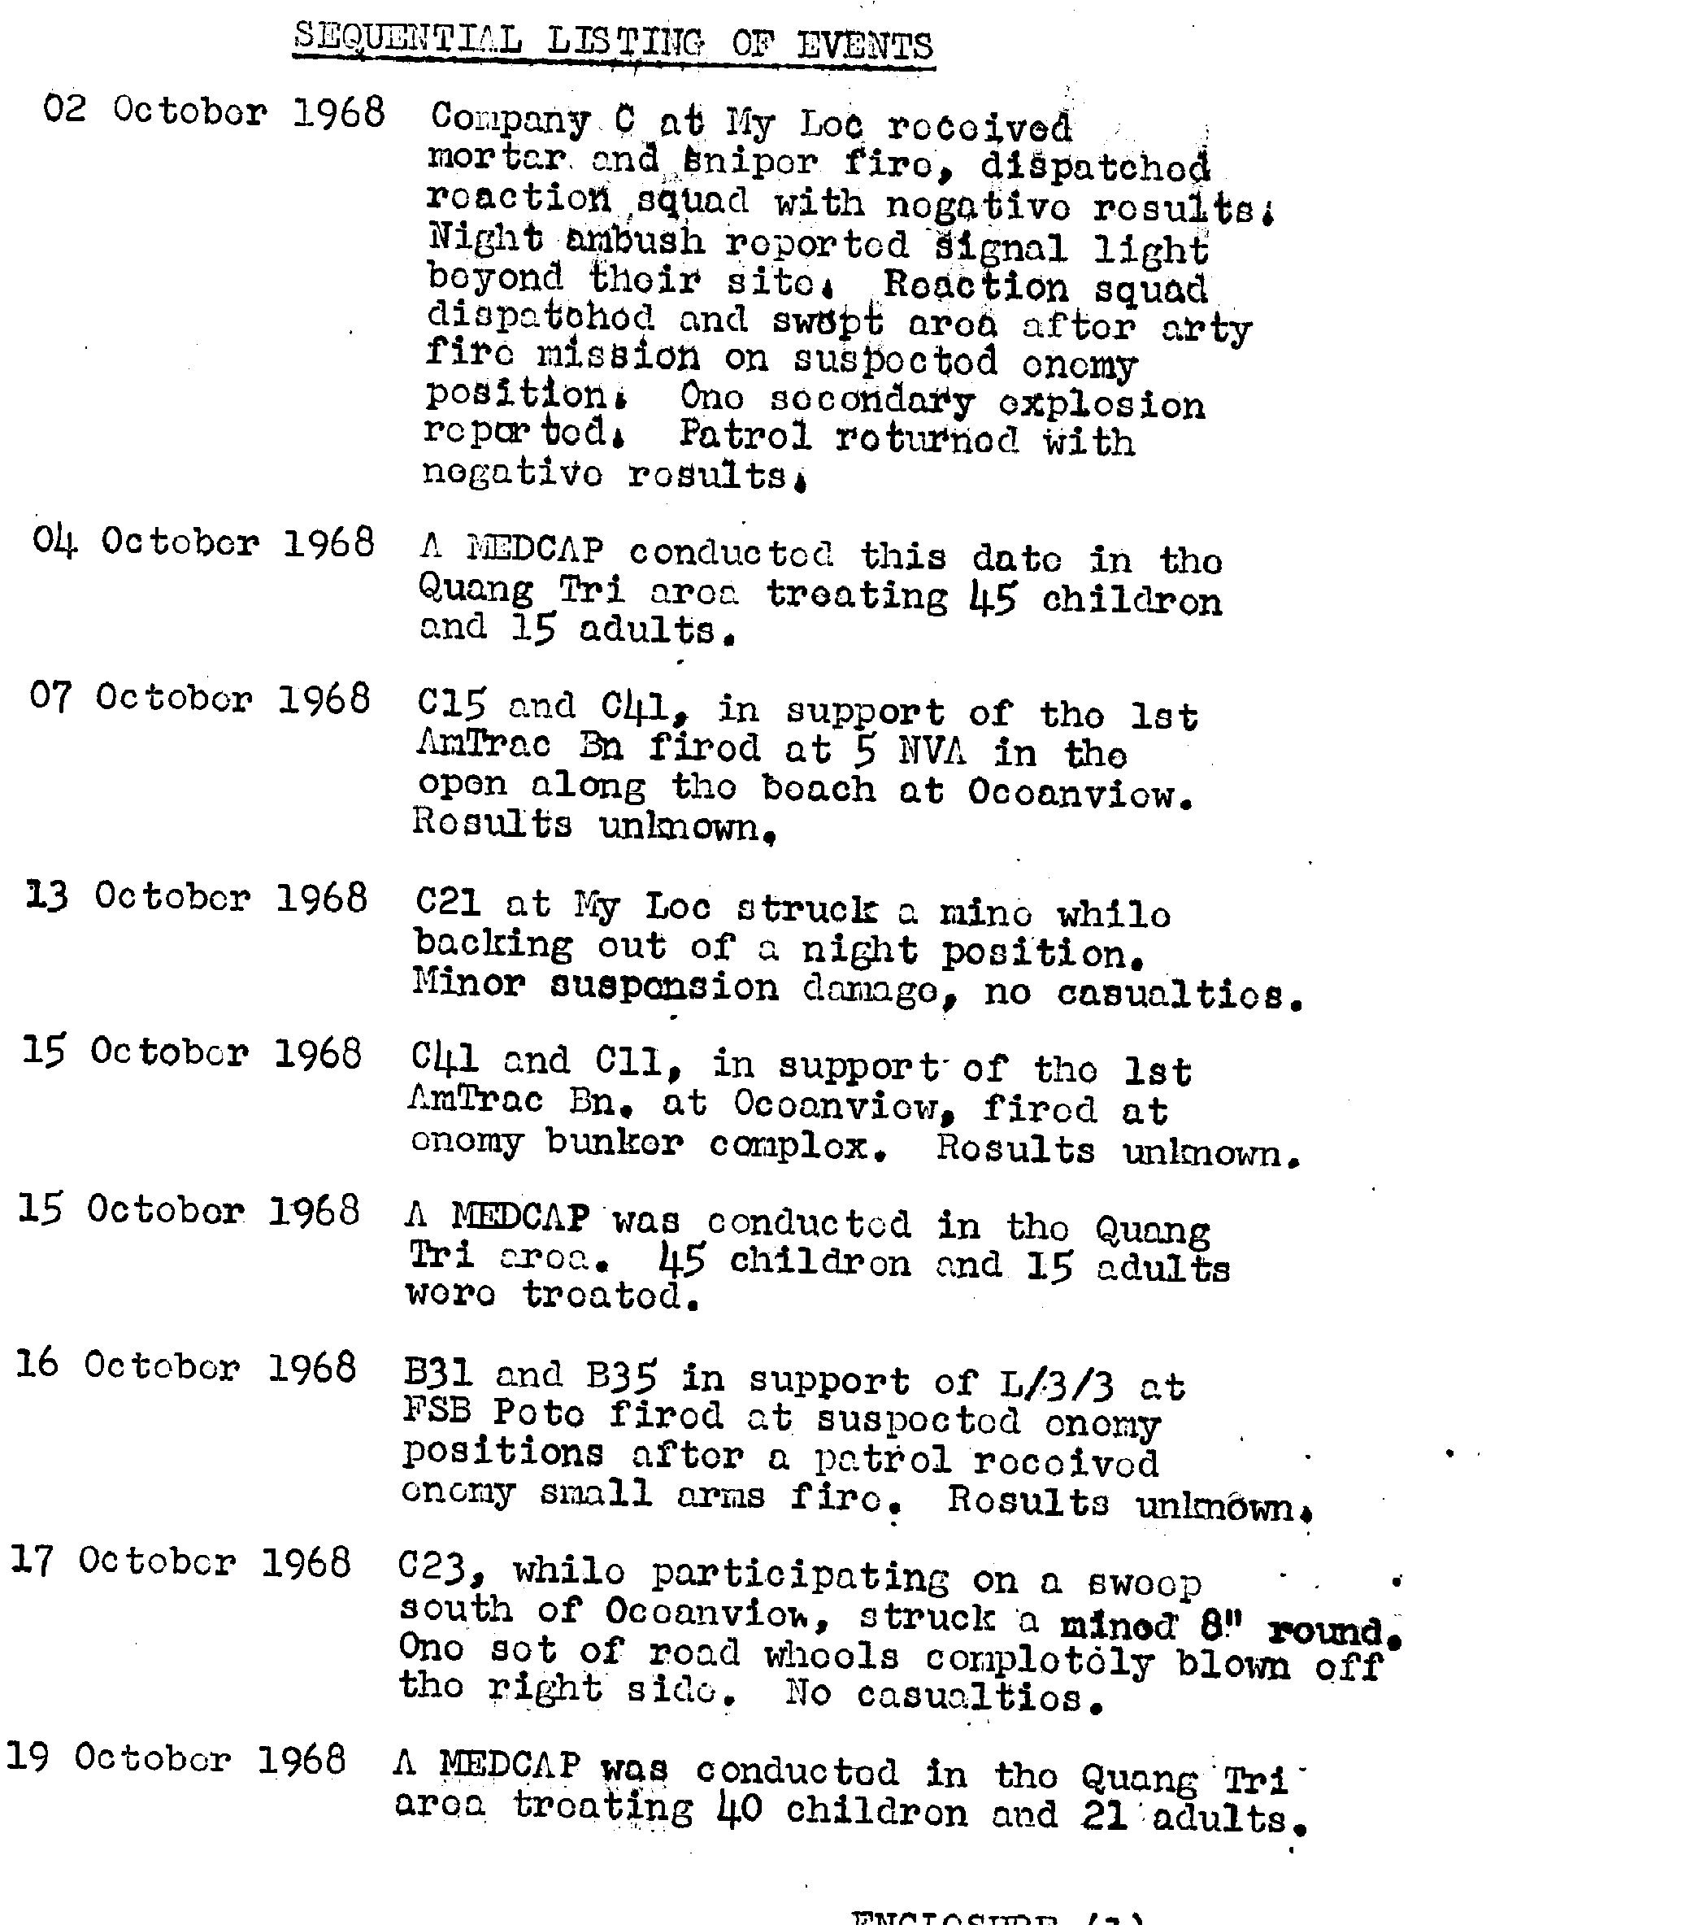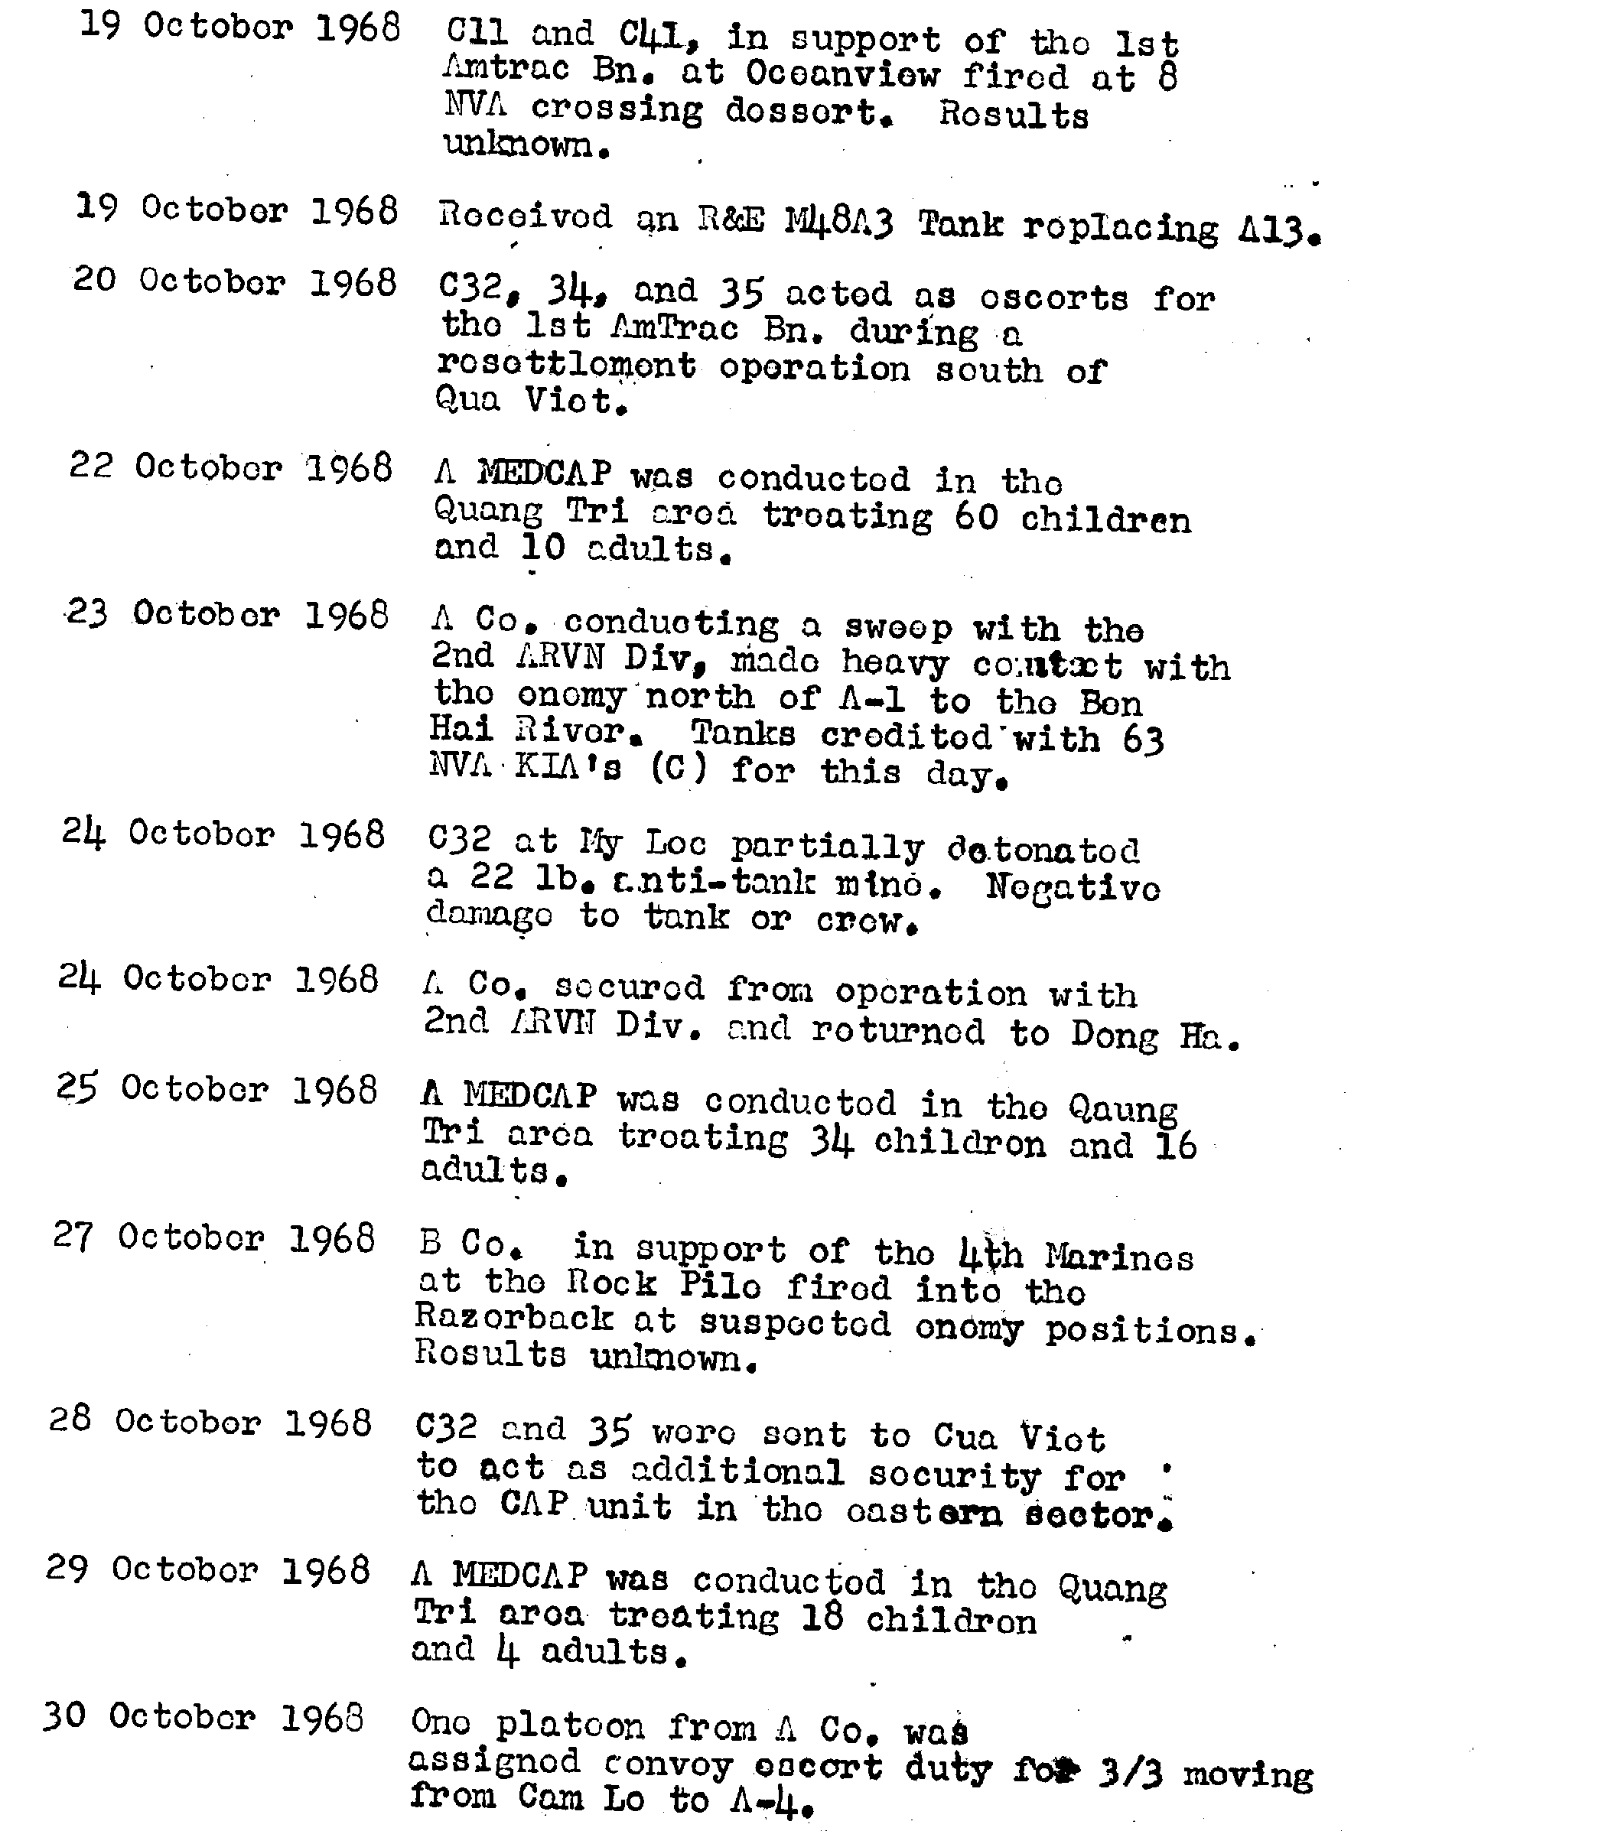

H&S Company C.O.: Capt J.A. Rumbley
Location & Operations Summary: Quang Tri

C.O. Company “A”: Capt R.J. Patterson
Location & Operations Summary: Dong Ha
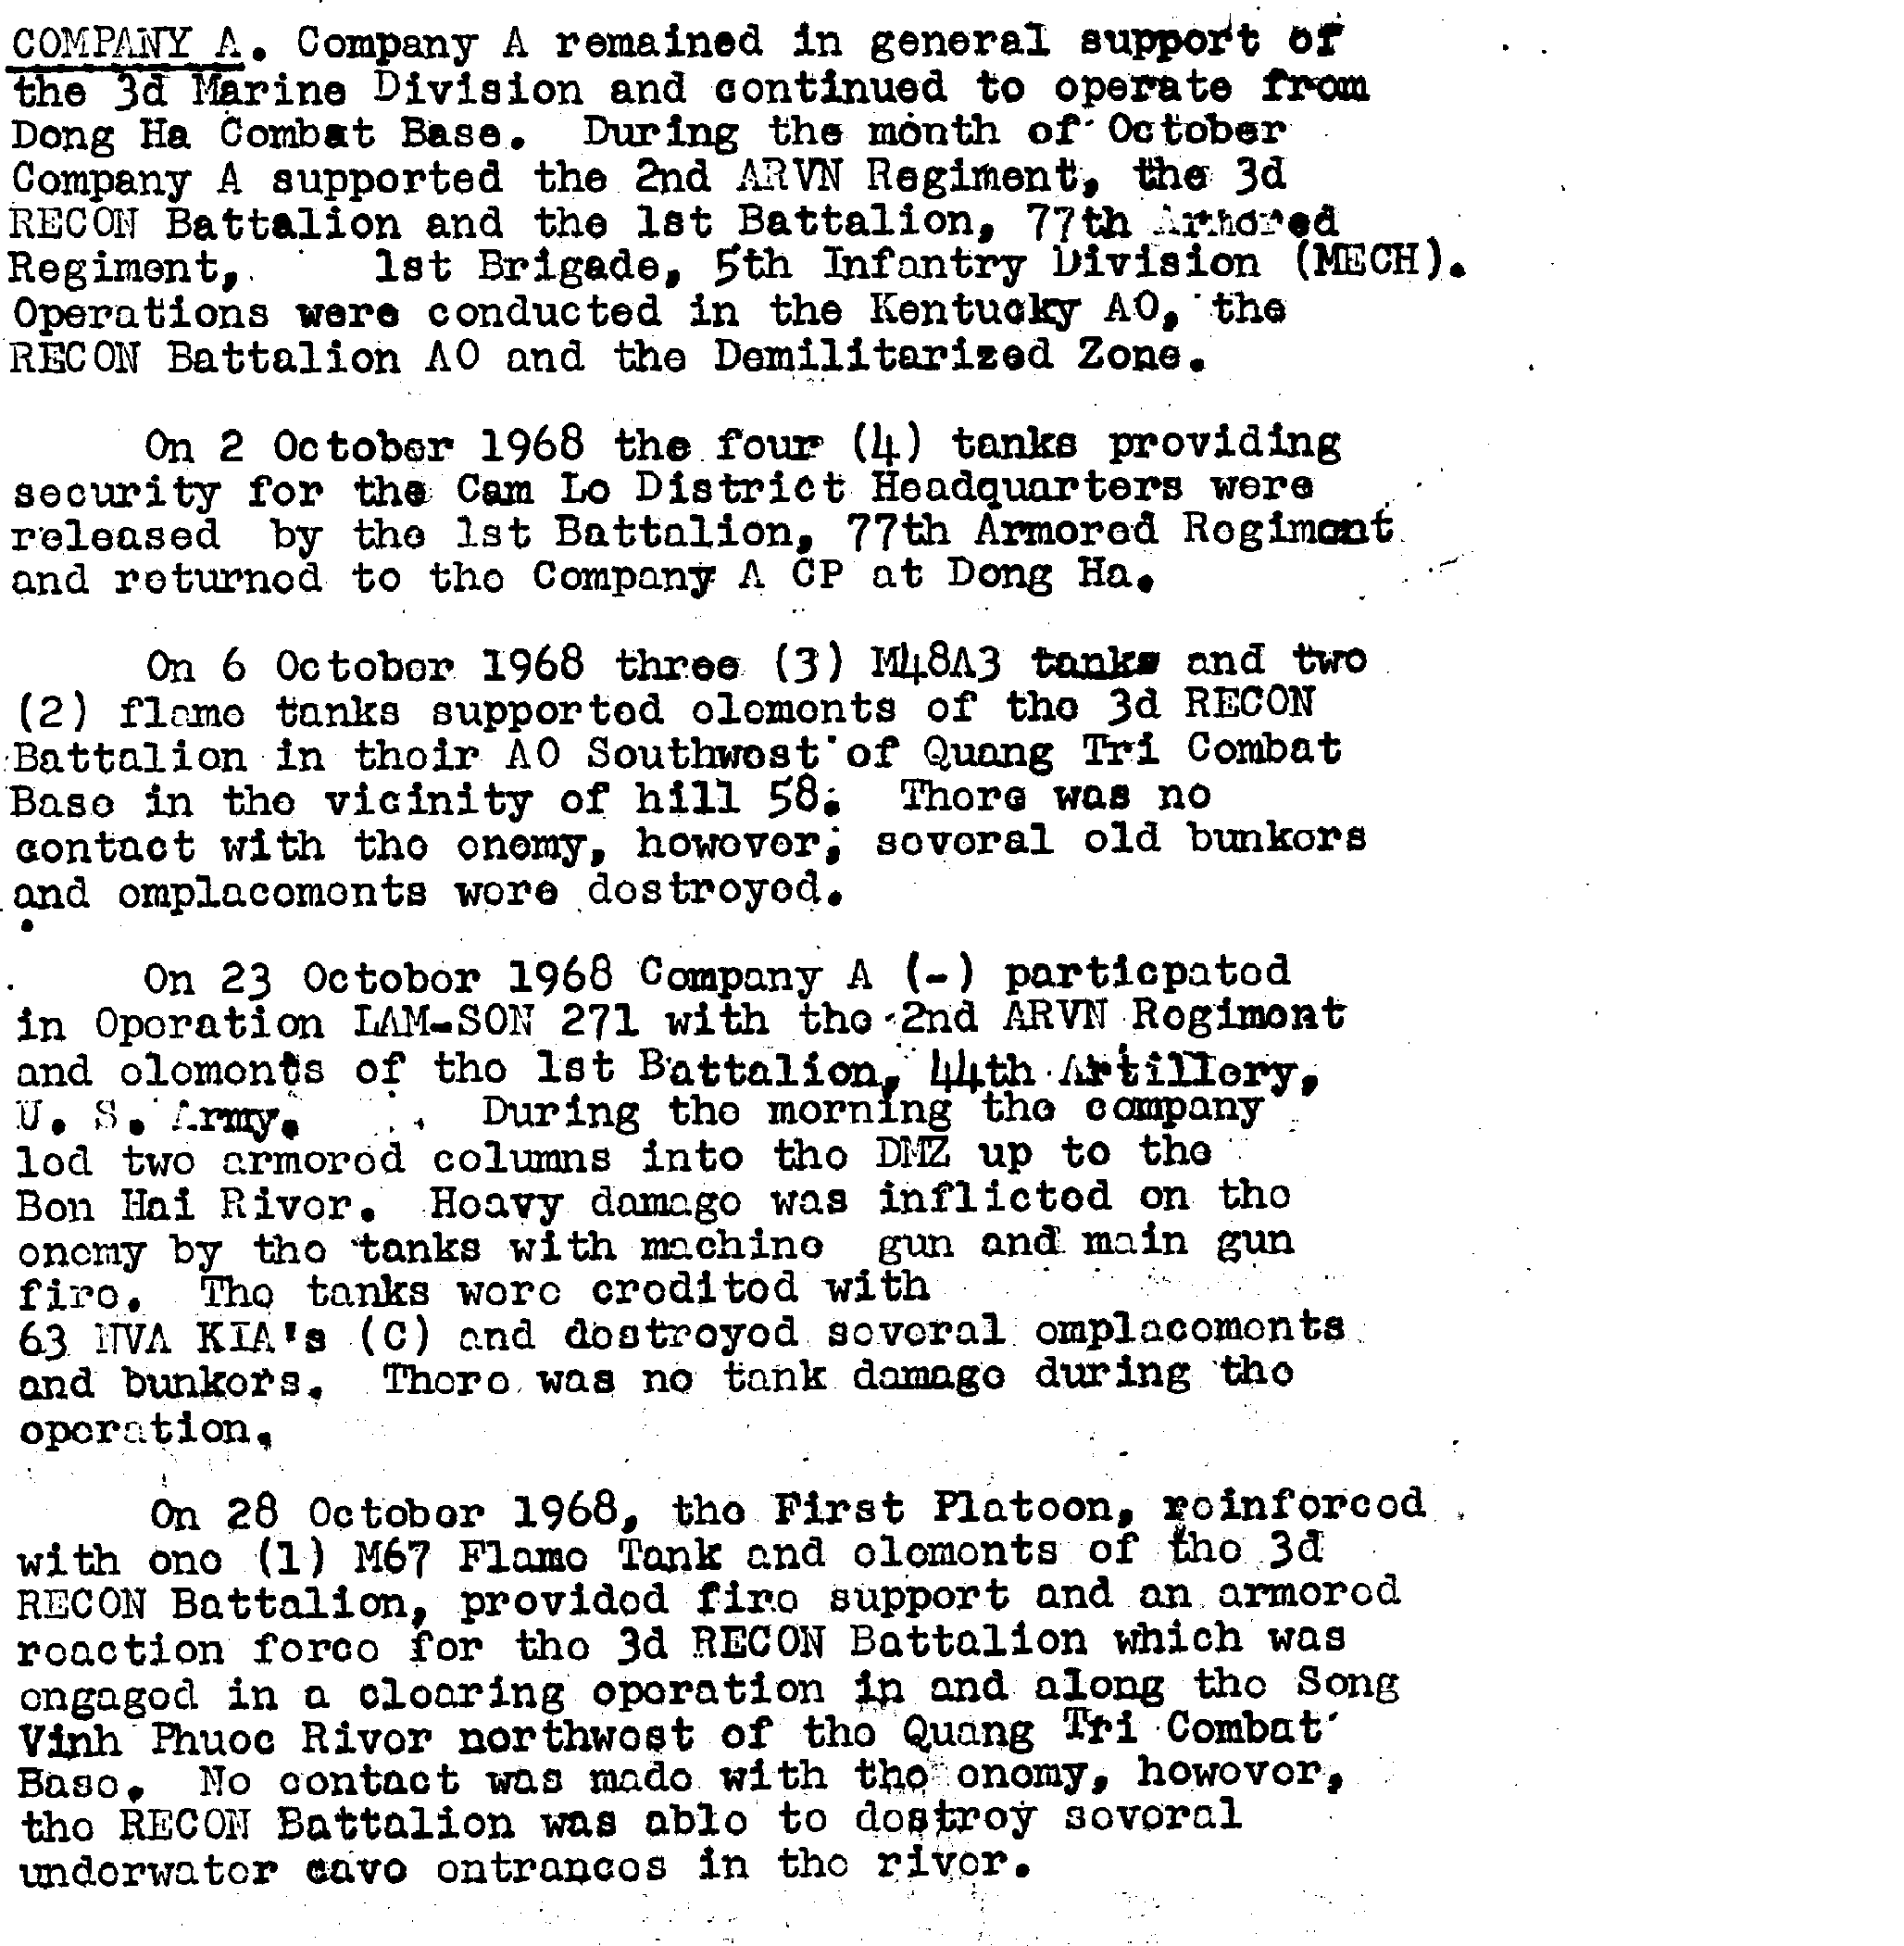

C.O.'s Company “B”: 1stLt J.T. Miller
Location & Operations Summary: Camp J.J. Carroll

C.O. Company “C”: Capt L.C. Kutchma
Location & Operations Summary: Hai Xa Tei
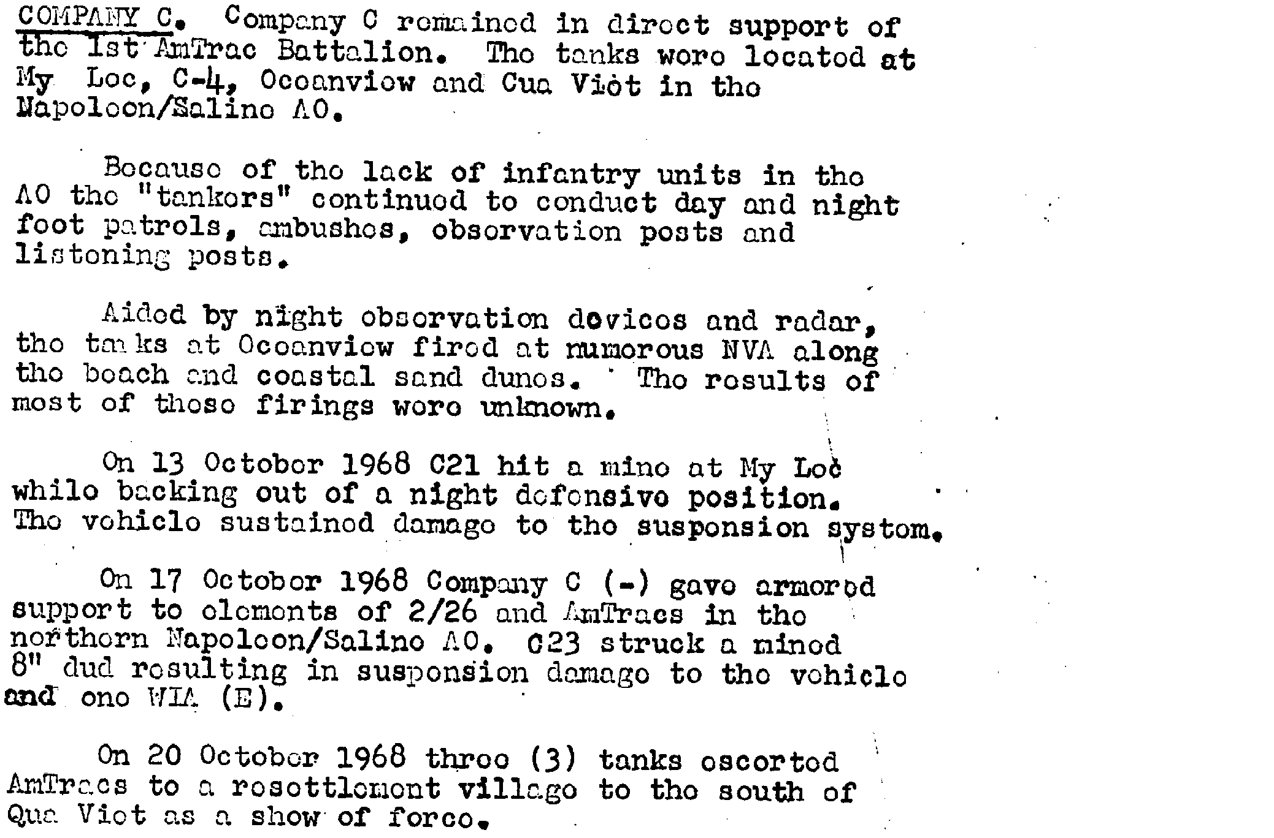

C.O. Company “A”, 3rdATBn: 1stLt F. Gypin Jr.
Location & Operations Summary: Quang Tri
October 1969

Third Tanks
Commanding Officers: LtCol's W.S. Rump & R.W. Martin, Jr.
Executive Officers: Maj's J.R. Bathis & A.E. Lee
Operations Officers: Capt's L.V. Yanda & F.T. Klabaugh
Logistics Officer: Capt M.H. Collier & Maj J.R. Balthis
Location & Operations Summary: Quang Tri
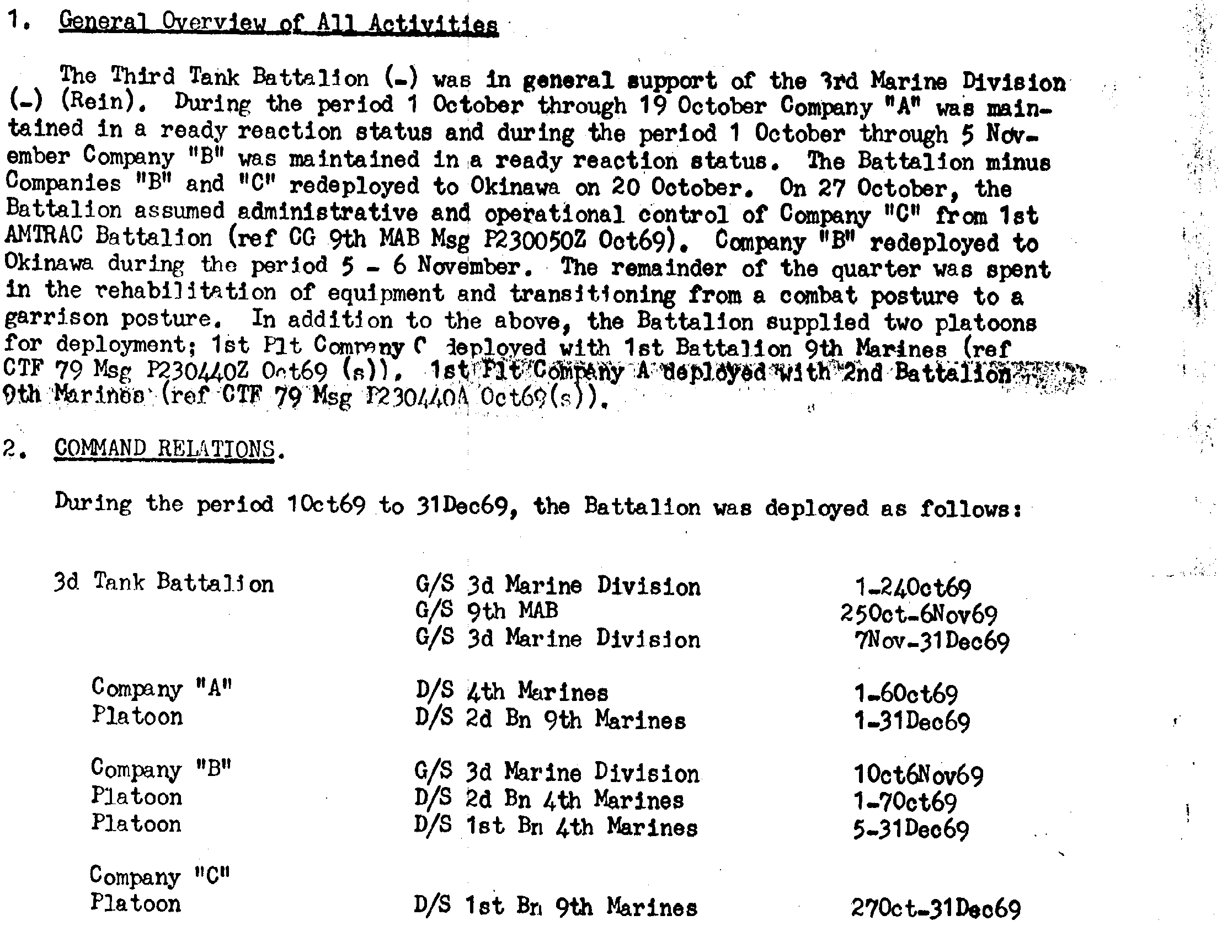

H&S Company C.O.s: Capt M.H. Collier & 1stLt G.L. Rivera
Location & Operations Summary: Vin Dai/En route to Camp Hansen, Okinawa

C.O. Company “A” (-)(Rein) Capt C.E. Hobbs
Location & Operations Summary: VCB/Quang Tri/En route to Camp Hansen, Okinawa

C.O.s Company “B” (-)(Rein): Capt's W.N. Crafton & L.V. Yanda
Location & Operations Summary: Vinh Dai/Dong Ha/Cua Viet/En route to Okinawa

Company "C": Camp Hansen, Okinawa

October 1965

Third Antitanks
Commanding Officer: LtCol B.A. Heflin
Executive Officer: Capt O.R. Edmondson
Operations Office: Capt V.A Vernay
Logistics Officer: Capt S.R. Stewart
Location & Operations Summary: (AT 987711)

H&S Company Commandants.: 1stLt's J.C. Rooney & D.B. House
Location & Operations Summary: DaNang TAOR (AT 987711)
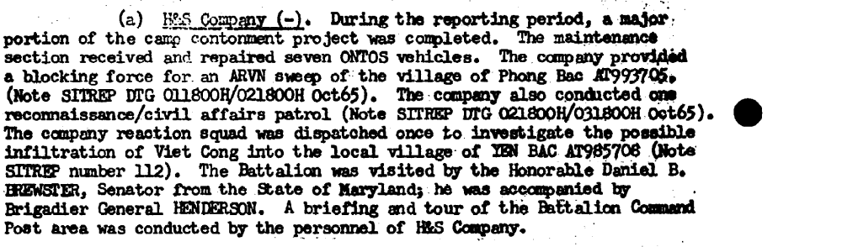
Company "A" C.O. (-) (Rein): Capt K.E. Sharff
Location & Operations Summary: (Da Nang TAOR/Hue Phu Bais TAOR)
Company "B" C.O. (Rein): 1st Lt M.H. Chang
Location & Operations Summary: (Chu Lai TAOR)
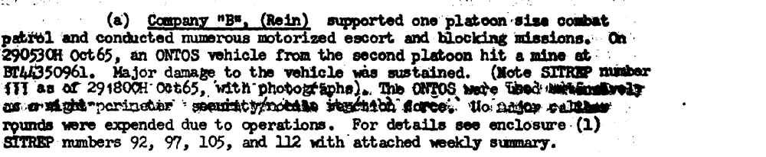

Company "C" C.O. (Rein): 1stLt A.G. Anderson II
Location & Operations Summary: (Da Nang TAOR)
Company "C" C.O. (-) (Rein), 1stATBn: 1stLt W.P. Snyder
Location & Operations Summary: (Qui Nhon Headquarters)

October 1966

Third Antitanks
Commanding Officers: LtCol D.E. Newton & Maj C.R. Stiffler
Executive Officer: Capt D.C. Satcher
Operations Officers: WO C.C. Harris & 1stLt J.C. Debilio
Logistics Officer: Capt D.C. Satcher
Location & Operations Summary: (Da Nang TAOR)

H&S Company C.O.: 1stLt D.K. Caswell
Location & Operations Summary: (Da Nang TAOR)
C.O. Company “A”(-)(Rein): Capt A.A. Compton
Location & Operations Summary: (Phu Bai TAOR)

C.O. Company “B”: 1stLt S.L. Camby
Location & Operations Summary: (Phu Bai TAOR)

C.O. Company “C”(-): Capt S.T. Flynn
Location & Operations Summary: (Phu Bai TAOR)

C.O. Company “A” (-)(Rein), 1st ATBn (OpCon 3rd ATBn): Capt D.M. Hutson
Location & Operations Summary: (Da Nang TAOR)
October 1967

Third Antitanks
Commanding Officer: LtCol G.M. McCain
Executive Officer: Maj R.M. Jordan
Operations Officer: Capt J.O. Lee
Logistics Officer: Capt B. Hastings
Location & Operations Summary: Gia Le CB

H&S Company C.O.: Capt A.W. Hoof
Location & Operations Summary: Gia Le CB

Company "A" (-) C.O.: Capt R.C. McInteer
Location & Operations Summary: Khe Sanh CB

Company "B" (Fwd) (-) & (Rear) C.O.: 1stLt A.U. Schultes
Location & Operations Summary: Camp Evans & Gia Le CB
Company "C" (Rein) C.O.: Capt T.J. Solak
Location & Operations Summary: Dong Ha TAOR

